**Information Adobe Photoshop**

**Introduction:-**

**Multimedia:-**Multimedia is the use of a computer to present and combine text, graphics, audio, and video with links and tools that let the user navigate, interact, create, and communicate.

Adobe Photoshop

Adobe Photoshop is software that is extensively used for raster image editing, graphic design and digital art. It makes use of layering to allow for depth and flexibility in the design and editing process, as well as provide powerful editing tools, that when combined, are capable of just about anything.

It was created by brothers Thomas and John Knoll in 1988. In 1989, John sold the program to Adobe Systems, which marketed it as “Photoshop.” Since then, the program has become the de facto industry standard for raster graphics editing. It is published for both maces and Windows, but not Linux.

**The Importance of Adobe Photoshop**

There are various advantages to learning Adobe Photoshop for individuals and professional web designers. Now we are going to discuss a few of them on below:. You can express your creativity:

Photoshop has several distinctive tools that will assist you better. Here you can get hundreds of themes, eye-catching effects, adjust contrast, exposure, and more in one click. So, when you will use Photoshop, you’ll be able to express yourself creatively.

### Create graphic design for a website:

If you’re running a business website, then you must need the help of Photoshop. Today, having a powerful and eye-catching online presence is crucial to each business. So, to enhance the business, you must need editing of your business-related pictures, which will give you success in high. You can use Adobe Photoshop are to design website landing pages, sales funnel design. As well as, you can design your product logos, contact us form, social media icons and more.

**Thomas and John Knoll**

Photoshop was developed in 1987 by the American brothers **Thomas and John Knoll**, who sold the distribution license to Adobe Systems Incorporated in 1988. Photoshop was originally conceived as a subset of the popular design software Adobe Illustrator, and Adobe expected to sell a modest several hundred copies per month.

### Thomas Knoll

### Use Adobe Photoshop to create a passport/stamp size photos:

From the admission form to the official work, the passport picture has become a much-needed thing nowadays. You can create a passport or stamp size photographs instantly using the camera of your phone and printer.

### You can create attractive t-shirt design:

Now people love graphics t-shirts which have high interesting images and fonts. By taking the advantages of Photoshop, you can create an excellent jersey style. After completing the process, then contact a garment manufacturer for printing them. This is another way you to start your own home-based job where you have don't need huge money to invest.

### Correction your photography mistakes very easily:

If your photograph doesn’t look very smart due to shadows, red-eye effect, and poor lighting, So you’ll be able to enhance that in Photoshop. You can use a brush to edit marks or crop some parts of an image if it is unnecessary.

### Mixing graphics with the text:

Now it's not possible for all kinds of businesses to possess their promoting materials done by printing presses. They have not enough time to create business cards, leaflets, logos, and

promoting materials for design. In Photoshop, you have a great chance to mix the graphics and text. So you’ll be able to create even more attractive images. However, to create a wonderful graphic design you must learn the technique to blend images with text.

Finally, we want to say, Adobe Photoshop is an excellent working tool for professional web designers or students. Adobe Photoshop helps to explore creative thinking and thoughts. Students will learn numerous skills in order to keep their invention works. Now there are different types of Photoshop alternatives offered on the web. But it has many versatile versions to suit people's needs and their work, which will be more productive in the coming days.

**Activity ; Create a Flyer or Advaertisement For Social issue**

Flyers are a tried and true method of drawing attention to your business, providing people with basic information and a call to action to look out for your company on their own. Even in the age of digital marketing campaign initiatives and online publishing, flyer design is still important.

If you’re looking to create a [real estate flyer](https://publuu.com/real-estate-flyer-maker/) that showcases your property listings and captivates potential buyers, or an event flyer that guarantees a queue at your open house, the tips listed below will help you craft visually appealing and effective marketing materials. After reading this article you’ll be able to create your flyer for any opportunity.

## How to create an outstanding flyer in 7 steps

Designing business flyers for your company is a great strategy. These materials don’t cost a lot to make and it’s easy to produce. Anyone can design elements of a perfect flyer, without the need of hiring a graphic designer. All you have to do is just find simple software and think about the flyer designs you want to create!

### Step 1 – Work on your content

The content of your promotional flyer is precisely your marketing message that will reach your target audience. This means that you should include as much information as possible while ensuring that the content of your flyer is simple and concise. Due to the size of a typical flyer template, you are limited in the number of words you can write; usually, it’s less than 500 words.

To make the information in your business flyer easier to understand, you can break it down into bullet lists and subsections. This way you will get your audience’s attention and give the reader answers to specific questions that may come to mind. Tell them what you offer, how they can contact you, how they can find you and what advantages you have over your competitors. Add your social media handles to let them find you easily.

### Step 2 – Craft an attention-grabbing headline

Your headline shows what you want to say. Whatever its content, make sure it is in a large, clear font and contrasts with the background of your flyer template. Graphic designers know that it is the headline that conveys the content to readers through the most prominent and extensive text on the leaflet page.

You need to use a large font, bright colors, or something else to make sure the title is the first thing readers see when they look at your leaflet. Take care that the flyer template uses contrasting colors to create eye-catching flyers.

### Step 3 – Work on your visuals

Good graphics ensure that the reader knows who the message is coming from, regardless of what is written on the actual business flyers.

To make sure people remember your company and its services make sure your brand colors and other elements are memorable and stand out when creating flyers. Include your company logo, slogan, and URL on your business 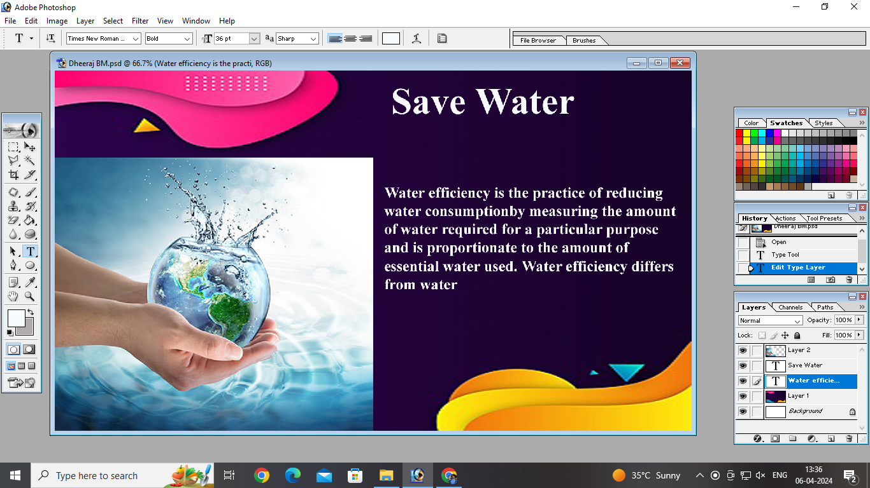

Many companies use a specific font for their brand, brand colors, iconic models, or other design elements, like mascots. Select also a well-matched background image that sums up everything about your perfect flyer.

You can use stock images or your own photos since it really depends on the industry. Professional designer tips recommend also using vector graphics, like cartoons or drawings. It all depends on your brand, the type of your company, and the people you are trying to reach.

### Step 4 – Pick a good flyer template

By this point, you or your content marketing manager have a clear and effective flyer copy text. Now it’s time to put it together using a good flyer design idea. There are many professional flyer templates available online. If you’re not a specialist in design elements, it’s probably best to create marketing materials using templates prepared earlier.

Pre-generated graphic design still allows you to create beautiful flyers by adding your own images, and brand fonts that take care of negative space. Designing concept gallery is far more efficient than starting out with a blank canvas. Flyers tend to be quite similar anyway – and the important thing is that a well-designed flyer gives the one key message about your brand – your mission statement.

 Step 5 – Use Publuu to publish your brochure

Do you want to present your well-designed brochures? You need to look no further. When it comes to designing stunning brochures, eBooks, promotional materials, and a myriad of other things, [Publuu](https://publuu.com/) is your answer to all your design needs. You can easily create your flyers by turning them into a digital PDF document with Publuu.

Using an interactive online brochure is a great idea for your business. It can reach millions of people if you share it on your social media – and Publuu, unlike other flyer-sharing services, generates a cover image automatically. Anyone with a link has access to your brochure on any device – and you can use robust analytics service to learn who reads your brochures and what aspects of them draw their attention.

Presenting your PDFs in a way that is both up-to-date and professional will definitely help you stand out from the crowd. The digital brochures created with Publuu always have a clean and contemporary appearance, drawing the attention that your content should receive. With Publuu’s online brochures you can make quick changes to them, share them easily, and monitor how well they perform online all in one place.

When the readers page through them, Publuu’s brochures make a distinctive sound and give off realistic shadows and reflections. This makes your [brochure design](https://publuu.com/knowledge-base/brochure-design-tips-and-tricks/) look as if it was really printed. All it takes is registering to take Publuu’s brochures’ many wonderful features to the test.

 Step 6 – Use a good design program

Flyer design needs at least some [good software](https://publuu.com/knowledge-base/the-best-booklet-maker-software-online/) to let syou work on revolutionary flyer designs. Pick a program with the largest free flyer template gallery – like Canva or, if you’re more experienced with flyer design, Adobe InDesign.

There are many programs to edit and print flyers on the market. Pick versatile software, that will let you work on many different elements and types of flyers. If you start with event flyer design, it’s not unlikely you might move off to design a flyer for your wares. Don’t buy a new graphic design tool each time when you want to create unique flyers – read up on the versatility of a tool you find user-friendly.

### Step 7 – End with a clear call to action

A call to action is the cornerstone of any marketing message. Take a moment to think about the most important part of your leaflet. Invite customers into the shop, persuade them to buy, invite them to the opening – they won’t know what to do if you don’t tell them. End the paragraph with a call to action.

Always end your text with a call to action for those reading it. This can be the last words of the paragraph, but also, for example, a sticker that says buy now. It can also be a discount incentive – -15% with the presentation of this leaflet.

## Flyer design tips

Your flyer design should stick to a consistent look. For the main headlines, stick to the same typeface and color scheme. When it comes to text, don’t be afraid to use different fonts and colors, and use a consistent color palette. The flyer example gallery we show below can present great, well-thought color schemes.

Organize all elements linked together into a single coherent whole. Link columns together, use equal spacing between paragraphs, and don’t break up words with graphic elements. Use the blank white space to create a non-overwhelming visual feel and the visual hierarchy of natural headers and fonts.

Your texts should be short and sweet. This is especially true for smaller leaflet size types, such as A6, and A5, which have limited space. Two sides of a flyer are usually enough to make your flyer grab people’s attention, though.

Nevertheless, don’t be afraid to be unconventional with your flyer design, and try out new solutions and ideas. Think about what your readers expect and provide them with information in the opposite way. Of course, stick to the main design tips we provide above – match the official style to the business flyer, for example.

Remember, however, that the most effective way to distribute content is to put the most important information on the first page and more detailed information on the second. Include your company name and contact details, like your social media handle or website address, on one side of the leaflet.

 The best flyer maker apps

1. There are many flyer design apps you can use to create the perfect flyer design you need. Some might be perfect for smaller companies – especially if they are useable for free. The paid solutions have more capabilities, but even a beginner can create an eye-catching design with the simplest flyer templates.

 Adobe Illustrator

[Adobe Illustrator](https://www.adobe.com/products/illustrator.html?skwcid=AL%213085%213%21601096058101%21e%21%21g%21%21adobe%2520illustrator&mv=search&sdid=KCJMVLF6&ef_id=EAIaIQobChMIvLrv34nz-AIVT-qyCh0u1gP1EAAYASAAEgKPu_D_BwE%253AG%253As&s_kwcid=AL%213085%213%21601096058101%21e%21%21g%21%21adobe%2520illustrator%211478481577%2158339249438&gclid=EAIaIQobChMIvLrv34nz-AIVT-qyCh0u1gP1EAAYASAAEgKPu_D_BwE) allows users to draw elaborated illustrations and organize all their works with this official Adobe program. You can use Illustrator Draw with mobile devices as well – it offers many of the basic functionalities of the program. It offers layers and many different styles of pens. You can easily edit your leaflets and export the files in many different file formats. Adobe Photoshop and InDesign also allow you to customize your documents and use various different style templates.